

**YEAR: 10**

**2017**

**SUBJECT: Science**

**NAME:**

**FORM:** **DATE:**

**TEST: Cosmetic Science**

**TIME: 45 minutes**

**QUESTIONS: 13 Short Answer (68 marks)**

**Answer all questions in the spaces provided.**

Total

**%**

**/68**

1. Explain what the term “ethics” means and give one example of an ethical dilemma related to the cosmetic science industry. (2 marks)

**Ethics are a set of guidelines (1) for behaving morally.**

***Any appropriate example (e.g. animal testing, microbeads) – 1 mark***

1. Label the three layers of hair in the diagram below: (3 marks)

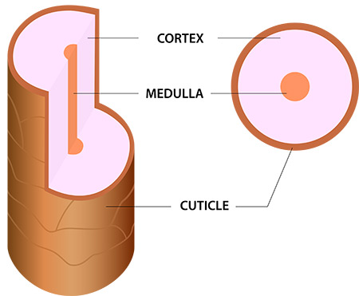

**A**

**B**

**C**

1. Match each layer of hair with its correct description by placing the corresponding letter in the table below: (3 marks)

|  |  |
| --- | --- |
| **DESCRIPTION** | **LETTER (A, B OR C)** |
| Contains melanin which gives hair its colour | **A** |
| Made up of scales which overlap to protect | **C** |
| May be absent, fragmented or segmented | **B** |

1. As your skin produces sebum to coat and protect each strand of hair, over time this can make your hair look greasy or dirty. **Describe** how shampoo works to clean your hair and why it is better than water alone. *You may like to use a diagram to help explain your answer.* (5 marks)

**Sebum is oily and cannot dissolve in water (1).**

**Shampoo is detergent (1). Part of detergent binds to sebum/oil (1) and another part binds to water (1) so sebum/oil can be washed away (1).**

1. Why is it important to consider pH of shampoo and how does this affect the strength of the hair strand? (6 marks)

**Shampoo with low pH [acidic (1)] is better for hair (1) as it makes hair stronger (1).**

**Shampoo with high pH [alkaline/basic (1)] causes keratin to break (1), weakening or damaging the hair (1).**

1. Label the five parts of the tooth in the diagram below: (5 marks)

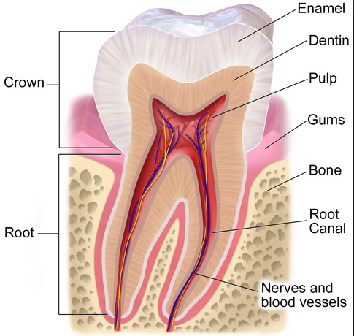

1. Fill in the missing information about the ingredients in toothpaste: (8 marks)

|  |  |
| --- | --- |
| **INGREDIENT** | **FUNCTION** |
| Abrasives | **Scrape off plaque/build up** |
| **Humectants** | Smooth & creamy texture |
| **Flavours/Sweeteners** | Pleasant, refreshing taste |
| Thickeners & Binders | **Prevents mess** |
| **Foaming Agent** | Makes foam |
| Sodium fluoride | **Protects against cavities** |
| Titanium oxide | **White colour** |
| **Sodium Hydroxide** | Increases pH |

1. Explain the role of fluoride in maintaining healthy teeth. *You may like to use a diagram to help explain your answer.* (7 marks)

**Enamel contains minerals – 1 mark**

**Bacteria produces acid (1) which dissolves minerals (1) and causes tooth decay (1).**

**Fluoride replaces lost minerals (1) and attracts other minerals to return to the tooth (1), making enamel stronger/more resistant to decay (1).**

1. Label the anatomy of skin in the diagram below: (6 marks)

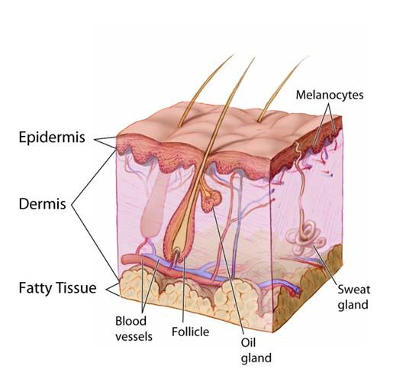

**vi**

**v**

**iv**

**iii**

**ii**

**i**

1. Match each label from the diagram of skin in question 9 to its function in the table below: (6 marks)

|  |  |
| --- | --- |
| **LABEL (i, ii, iii, iv, v or vi)** | **FUNCTION** |
| **v** | Location of hair growth for warmth and protection |
| **iii** | Insulation |
| **i** | Provides protection |
| **iv** | Carries oxygen and nutrition to tissues, removes waste products such as carbon dioxide |
| **vi** | Secretes sweat to keep the body cool |
| **ii** | Provides support and regulates temperature |

1. Describe the difference between UVA and UVB rays and state which ones SPF protects against. (5 marks)

**UVA rays penetrate to dermis layer (1) causes aging/wrinkles (1)**

**UVB rays burn epidermis layer (1) causes skin cancer (1)**

**SPF protects against UVB rays (1)**

1. Compare and contrast the two types of blockers in sunscreens and describe how each helps to protect the skin. (4 marks)

**Chemical blockers (1) absorb UV rays (1)**

**Physical blockers (1) form a barrier/reflect UV rays (1)**

1. Match the name of the ingredient with its function in skin care product by drawing a neat and clear line between each: (8 marks)

|  |  |
| --- | --- |
| sodium laureth sulfate | thickening agent |
| glycerine | adjusts pH levels |
| allantoin | foaming agent |
| stearic acid | helps remove dead skin cells |
| salicylic acid | acts as a lubricant and hydrates skin |
| sodium hydroxide | dries up blackheads/whiteheads |
| glycolic acid | conditioner and skin protectant |
| myristic acid | forms bubbles for faster foaming |